Note: The general guidelines for Project Execution Plan (PEP) are provided in the NSF Research Infrastructure Guide (RIG), see Table 3.4.1-1, Section 3.4.1. Specific guidance for mid-scale research infrastructure (RI) projects is provided in Section 5 of the RIG. This template is provided to aid in the development of a PEP for a mid-scale RI project.

Project Execution Plan
<<Project Title>>
<<Acronym for Mid-scale RI Project>>

Version July 2022
Revision #2.1

Template Change Log
<<The details in this section should be replaced with a change log for the PEP>>

Revision History
Rev. | Date | Reason
0 | August 2019 | Initial NSF approval for award
1 | October 2019 | Updated for first assessment and fund release
2 | July 2022 | Updated to improve alignment with Section 5.0 RIG.
3 | TBD | TBD
Table of Contents

<<Component numbers should be generated once the components are determined. It is recommended that the consideration be given and rationale be noted for additional sections, i.e. typical of major facilities, as listed in RIG Section 3.4 and Table 3.4.1-1.>>

INTRODUCTION 5
Scientific Objectives 5
Scientific Requirements 5
Divestment Plan 5
Organization 5
Internal Governance & Organization 5
External Organization and Communication 6
Partnerships 6
Roles and Responsibilities 6
Construction Project Definition 6
Summary of Total Project Definition 6
Work Breakdown Structure (WBS) 7
WBS Dictionary 7
Scope Management and Scope Contingency (as applicable) 8
Cost Estimating Plan, Executive Summary, and Baseline Budget 8
Budget Contingency 8
Cost Book, Cost Model Data Set and Basis of Estimate 8
Funding Profile 9
Baseline Schedule and Basis Document and Integrated Schedule 10
Schedule Contingency 10
Risk and Opportunity Management 10
Risk Management Plan 10
Risk Register 11
Contingency Management Plan (where applicable) 11
Configuration Control 11
Acquisitions 11
project management Controls (Methods for Performance measurement and Management) 12
Project Management Control Plan 12
Earned Value Management System (EVMS) Plan 12
Description of Financial and Business processes and controls. 12
Cyber-Infrastructure 12
Cybersecurity Plan 13
Code Development Plan 13
Commisioning AND Concept of Operations 13

List of Acronyms
<<This list should be tailored to the Project’s PEP and aligned with terminology in NSF RIG and/or the NSF PAPPG>>

AY Annual Year
BCP Baseline Change Proposal
CDR Conceptual Design Review
CPI Cost Performance Index
CY Calendar Year
EAC Estimate at Completion
ES&H Environment, Safety and Health
EVM Earned Value Management
FTE Full Time Equivalent Employee
FY Fiscal Year
L2 Level 2
LFO Large Facilities Office
NSF National Science Foundation
PI Principal Investigator
PEP Project Execution Plan
PM Project Manager
PO Program Officer
QA Quality Assurance
QC Quality Control
R&D Research and Development
SPI Schedule Performance Index
TPC Total Project Cost
WBS Work Breakdown Structure

INTRODUCTION

This Project Execution Plan (PEP) describes the management and project execution processes that are used to ensure that <<Project Title>> (hereafter, <<ACRONYM>>) scope is completed on time and within budget. The document defines the project scope, describes the organizational framework and overall management systems for the project, and identifies roles and responsibilities of the project participants. It also describes the formal change control process by which the Project scope, cost, schedule, budget profile, and PEP may be revised.

The PEP is a living document that will be updated to capture changes to project systems, processes, procedures and personnel and revisions to the approved performance baseline or other significant changes, as appropriate.

Scientific Objectives

<<Brief description of the research objectives motivating the mid-scale RI proposal.>>

Scientific Requirements

<<Comprehensive statement of the Requirements Matrix/ Key Science Requirements to be fulfilled by the proposed project (to the extent possible identifying minimum essential as well as desirable quantitative requirements), which provide a basis for determining the scope of the associated infrastructure requirements.>>

Disposition Stage Plan

<<Brief description of plans and estimate of disposition stage, particularly liabilities at the end of the proposed infrastructure’s life for transfer, demolition, decontamination, etc. (where appropriate).>>

Organization

Internal Governance & Organization

<<Internal Project Organization Structure with clear lines of authority, responsibility, and communication between NSF, any partners, and the Recipient.>>

[EXAMPLE: Insert Diagram Displaying Institution Internal Reporting / Relationship Hierarchy]

External Organization and Communication

<<External Project Organizational Structure and Governance, showing clear lines of authority, responsibility, deliverables, reporting and decision timelines, and communication between NSF, any partners, and the Recipient.>>

[EXAMPLE: Insert Diagram Displaying External Reporting / Relationship Hierarchy]

Partnerships

<<Roles of Interagency or international partners in future planning and development and/or construction. Plans, agreements, and commitments for interagency and international partnerships. Description of the project’s stakeholders and their roles, responsibilities, and meeting schedules.>>

Roles and Responsibilities

<<Roles and Responsibilities of key project personnel and governance groups.>>

Community Relations and Outreach

<< Community Relations and Outreach plans for building and maintaining effective relationships with the broader research community that will eventually utilize the facility to conduct research and with the public. Description of scientific and educational outreach programs.>>

Construction Project Definition

<<This section documents the Project’s Performance Baseline (PB), which consists of the project scope, total project cost (TPC), schedule, technical performance parameters, and other information related to the PB. Lower tier documents (such as resource loaded schedule, basis of estimate, cost book) will capture the details and plans of resource cost, schedule, scope, and project life cycle from initiation to closeout.>>

Summary of Total Project Definition

<<Summary at Work Breakdown Structure (WBS) level II of total construction project scope, cost, and schedule required to complete the construction or implementation project, indicating Performance Measurement Baseline (PMB) (post-award) and contingencies funded by NSF as well as any associated scope supported by other funding sources.>>

Work Breakdown Structure (WBS)

<<WBS contains a product-oriented, hierarchical framework that organizes and defines the total scope of the project into individual project component that represent work to be accomplished, aggregating the smallest levels of detail into a unified project description. The WBS integrates and relates all project work (cost, schedule and scope) and is used throughout the project management to identify and monitor project progress.>>

[EXAMPLE: Insert depiction of WBS with work packages to LIII]
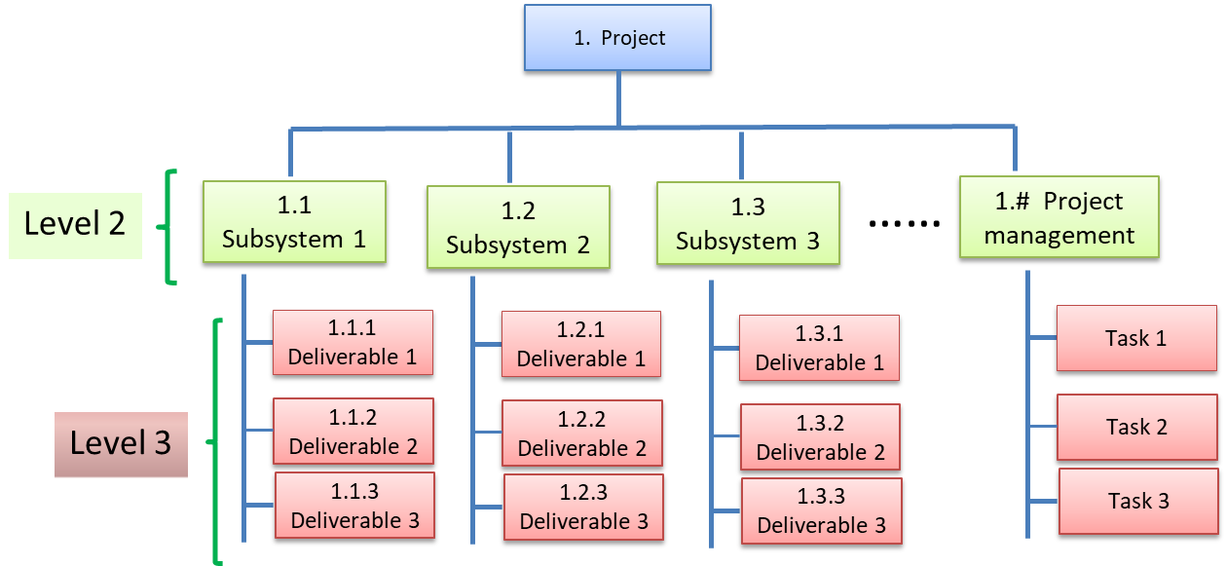

WBS Dictionary

<<WBS dictionary defining scope of each WBS element, through all levels.>>

[EXAMPLE: Table with Information for Dictionary]
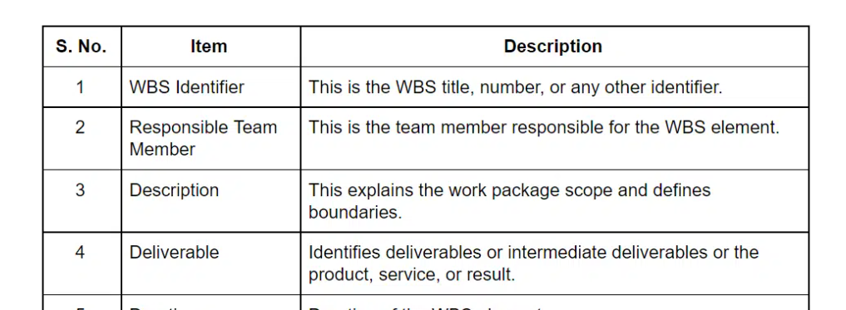

Scope Management and Scope Contingency (as applicable)

<<The plan describes how the scope will be defined, developed, monitored, controlled, and validated, and how scoping opportunities and descoping options will be realized. Scope Contingency compiles savings from potential de-scoping options, with decision points for exercising options and time-phased cost and schedule.>>

Cost Estimating Plan, Executive Summary, and Baseline Budget

<<A plan to establish and communicate how the preparation, development, review and approval of the estimate will be completed. An executive summary provides a summary of the costs at a high level and an overall basis of estimate.>>

[EXAMPLE: Table Summarizing Costs by WBS]
WBS Element | WBS Description | Total Cost  (FY$k) | Cost Account Manager (CAM)
1 | Project
1.1 | Example: Project Management
1.2 | Work Package
1.3 | Work Package
1.4 | Work Package
 | Sub total
 | Budget Contingency (as applicable)
 | Total Project Cost (TPC)

Budget Contingency

<<Contingency budget and description of method for calculating contingency, including confidence level for completing within budget (refer to Risk Management in the NSF RIG.>>

Cost Book, Cost Model Data Set and Basis of Estimate

[EXAMPLE: Cost Book Sheet]
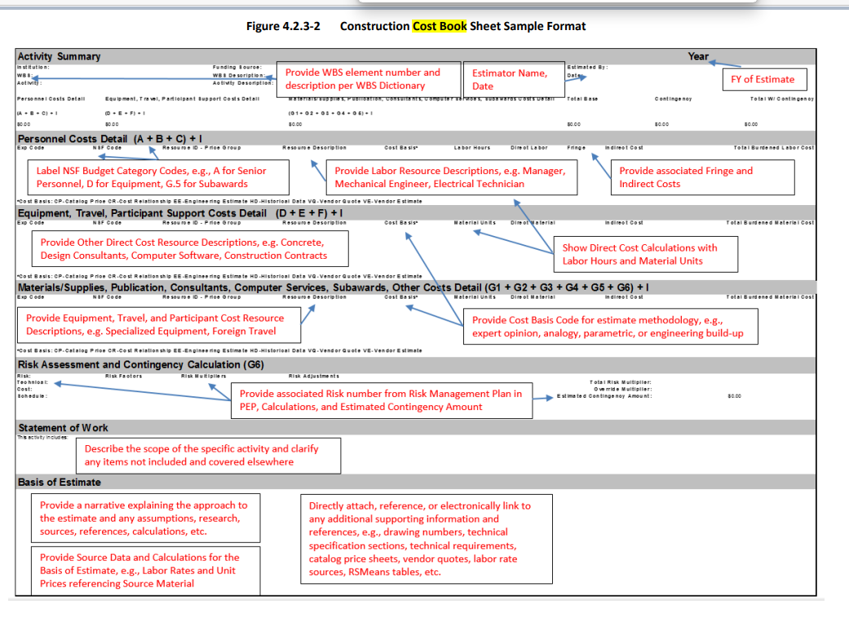
<< The Cost Book is the comprehensive and well-documented compilation of Cost Book Sheets for the total project cost. The cost model data set is used as input to software tools and/or project reports to organize, correlate, and calculate different project management information. The Basis of Estimate provides supporting documentation outlining the details used in establishing project estimates such as assumptions, constraints, and estimating methods, and referencing the technical information used.>>

Funding Profile

<<Show the proposed NSF Funding Profile by year (prefer Federal Fiscal Year (FY)) with baseline commitment for allocation profiles. Budget baseline does not include anticipated contingency, so include a separate row for Budget Contingency where applicable.>>

[EXAMPLE: Table Showing Funding Profile by WBS]

FY 20XX ($K) | FY 20XX  ($K) | FY 20XX  ($K) | FY 20XX  ($K) | FY 20XX  ($K) | Total

Baseline Schedule and Basis Document and Integrated Schedule

<< Baseline Schedule for the overall project and each major subsystem, including system integration, commissioning, acceptance, testing and transition activities; as well as major milestones and milestones for reviews, critical decisions, and deliverables. It uses formal scheduling programs, is based on the WBS hierarchy, and is resource loaded before the construction/implementation stage. Alike budget, contingency is not included in baseline.>>

[EXAMPLE: Table showing Key Level I and II Project Milestones and the Planned Dates for Completion]

WBS#/Milestone  (Brief Text of Activity) | WBS/Work package (Description) | Planned Completion Date  (mm/dd/yyyy)
Level I Milestone | High-level Description
Level II Milestone | More Detailed Description
Level II Milestone | More Detailed Description
Overall Project Completion

<<More detailed schedule (resource loaded schedule) can be attached as a separate file. For reporting of progress consider short-term milestones, long-term milestones, and critical.>>

Schedule Contingency

<< Schedule contingency amounts and project end date with contingency; state method of calculating contingency, including confidence level for meeting project end date. >>

Risk and Opportunity Management

Risk Management Plan

<<Describes the methodology/process for identifying, analyzing, tracking, controlling, and mitigating risks. Describes methods for both qualitative assessment and quantitative analysis. Refer to Risk Management section of the NSF RIG.>>

Risk Register

<< A tracking document or tool that provides a ranked list of identified risks, with risk impact analysis and prioritization, responsibilities, mitigation plans and opportunities of risk reduction, and risk status over time. Documents data and assumptions used in risk analysis. Consider quantifying the estimated mitigation of impacts in dollars and time.>>

[EXAMPLE: Risk Register]

Contingency Management Plan (where applicable)

<< Contingency management plans and approval process using change control. Describe NSF approval requirements per Grants and Cooperative Agreements (CAs).>>

Configuration Control

Configuration Control Plan

<<Clearly define communication and handling of technical and administrative changes impacting scope, Key Performance Parameters (KPPs), deliverables, and Performance Measurement Baseline (PMB), including monitoring, reporting, decision-making, documents.>>

Change Control Plan

<<Change Control Plan to manage accounting changes and changes in the baseline or PMB plan: changes in scope, modifications to budget or schedule, and movement of contingencies into or out of the PMB. Includes matrix of threshold, approval and documentation processes, and roles and responsibilities.>>

Document Control Plan

<<Document Control Plan for managing version control, access, and archiving of project related documentation.>>

Acquisitions

Acquisition Plans

<<Describe acquisition plans, processes, subawards, and contracting strategy, including discussion of evolving technologies and assumptions for design definitions. Provide a time/dollar-based list of acquisitions and procurement actions.>>

Acquisition Approval Process

<< Describe the approval process for acquisitions (internal, external, NSF), and create a year-by-year list of dates/actions that will require NSF approval.>>

[EXAMPLE: Insert Table with list of acquisitions by year, noting dates and actions that are estimated to require NSF approval.]

project management Controls (Methods for Performance measurement and Management)

Project Management Control Plan

<<Description of the project management organization and processes.>>

Performance Assessment Plan (Earned Value Management System (EVMS) if used)

<<Description of the EVMS (if applicable) assessment plans, processes, software, tools.>>

<<EXAMPLES: Other Performance Measurement and Management>>

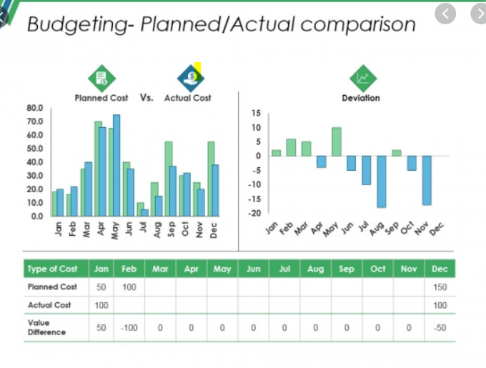

Description of Financial and Business processes and controls.

<<Description of Financial and Business processes and controls.>>

Cyber-Infrastructure

Cybersecurity Plan

<<Plan for protecting access, confidentiality, and integrity of key information assets.>>

Code Development Plan

<<Plan to enable critical scientific/engineering capabilities and data flows within the Research Infrastructure, interoperability with key external collaborator-stakeholders.>>

Data Management Plan

<<Plans for acquisition and integration of equipment or services from third parties, including legal agreements for a short- and long-term storage, maintenance, protection, divestment, and disposition.>>

Commisioning, including Concept of Operations

Integration and Testing Plan

<< Describes the acceptance criteria (e.g. Key Performance Parameters) and technical activities that should be completed as part of transition to operations.>>

Operational Readiness Plan

<<Plan for determining operational readiness; includes administrative (non-technical) acceptance procedures to transition the facility from construction to operations such as conducting the operational readiness review and the authorities for making the determination(s).>>

Concept of Operations Plan

<<Plans for, and estimate of annual operations and maintenance costs (staffing, services, material/supplies, etc.) and secured funding sources needed to operate RI. This plan should include activities to bring and maintain the RI at full science capability after acceptance.>>

Segregation of Funding Plan

<<Financial accounting procedures for the Recipient to properly expense the activities between construction and operations funding per the Plans above.>>

The components in this template align with the minimum requirements for the Mid-scale RI awards, as listed in Section 5 of the RIG. The contents of the PEP should include Sub-Topics listed in RIG Section 3.4 and Table 3.4.1-1 and be tailored in detail and scope to the solicitation.

